Perform the below steps after adding the SAP Plugins.

1. By default, in Eclipse the development perspective is JAVA. To develop ABAP objects the perspective, need to change to ABAP.

In the menu bar select Windows-> Perspective->Open Perspective->Other->ABAP.

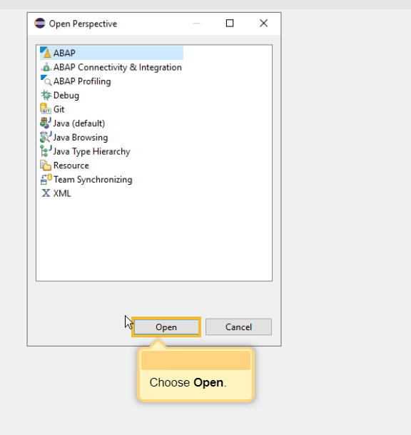

1. To create an ABAP Cloud project, go to the menu-> ABAP Cloud Project as shown below.

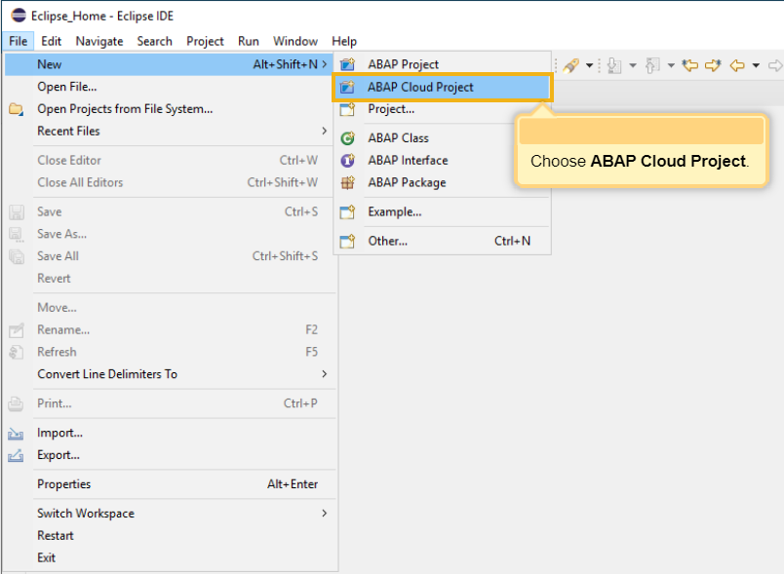

1. When the ABAP Cloud project is selected, there are two options displayed as shown below in which the Use a Service key is selected.

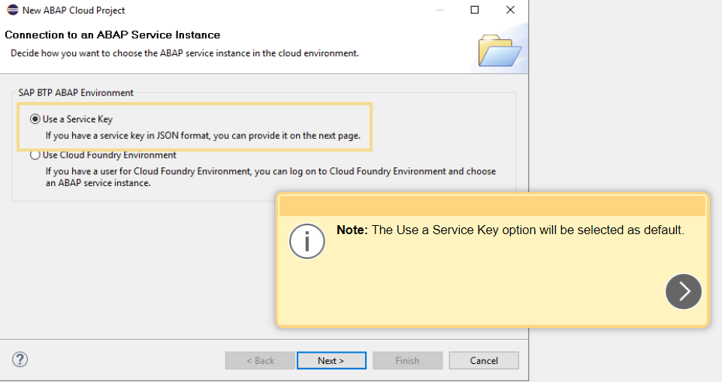

1. The service key is required to connect to the ABAP on the Cloud account.

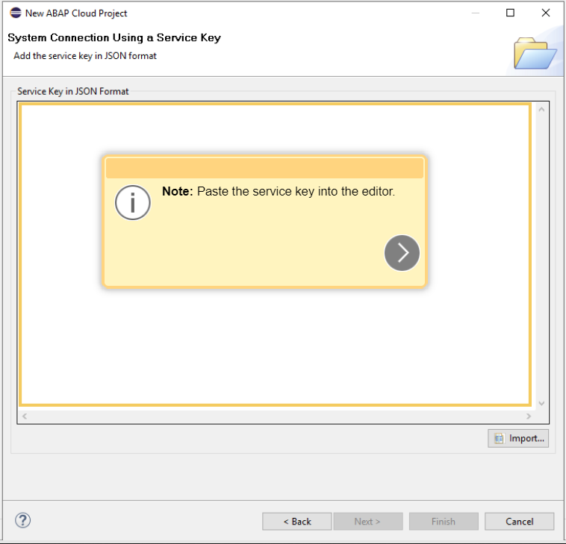

1. Log in to the SAP BTP Cockpit using the credentials and go to Trial Home.

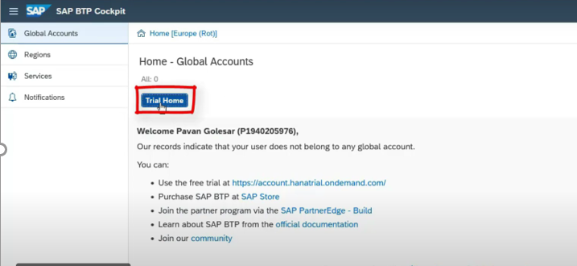

1. Go to your Trial Account.

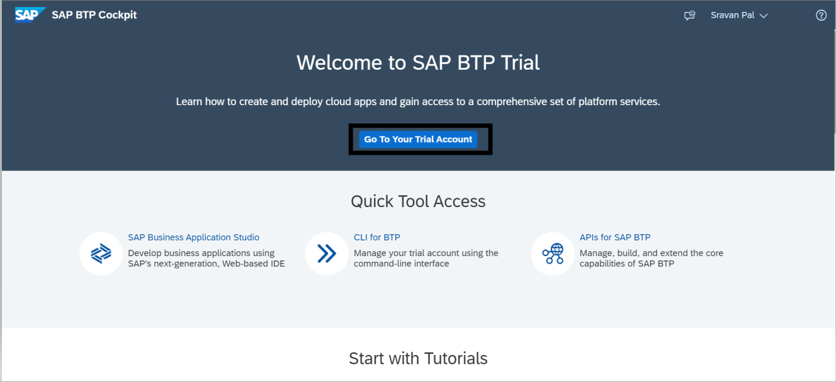

1. Go to Boosters -> Prepare an Account for ABAP Trial.

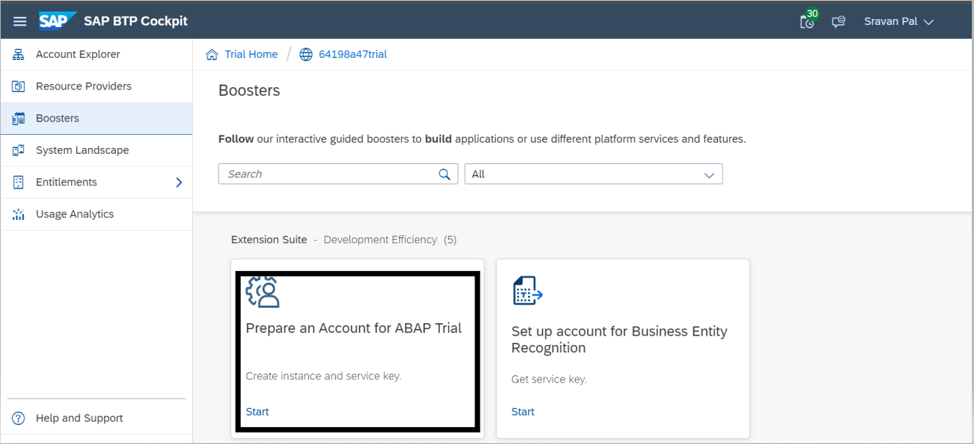

1. The Service key required for step 4 will be available here.

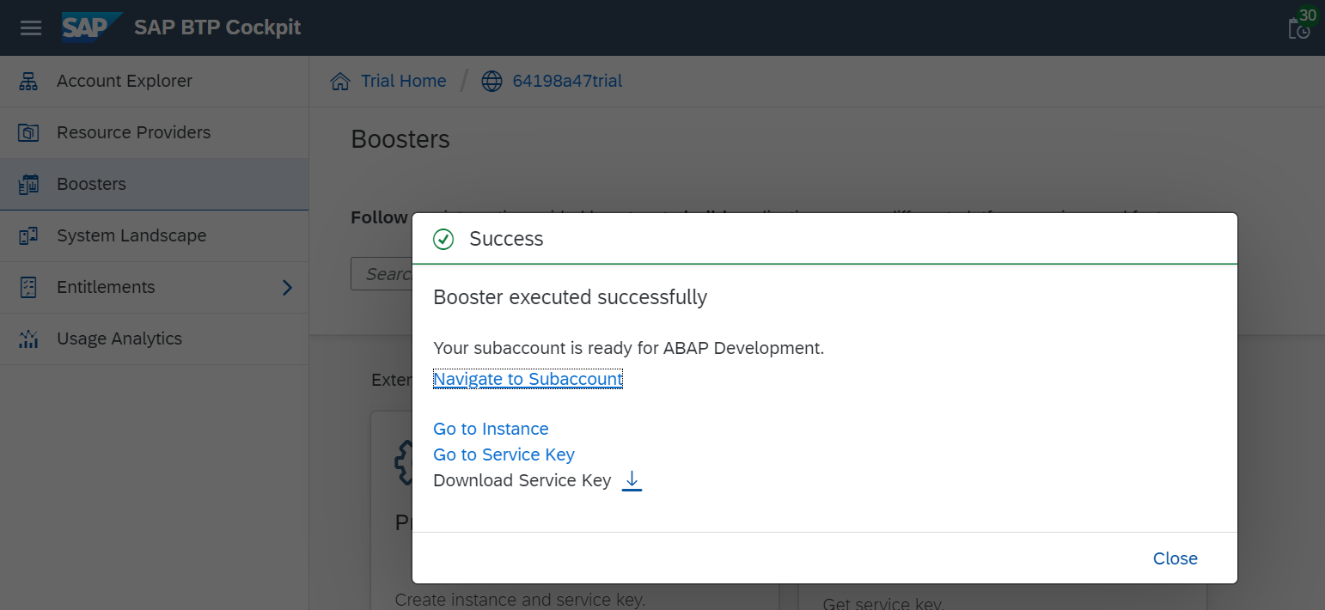

1. Download the service key and paste the same into the step 4 screen of eclipse.

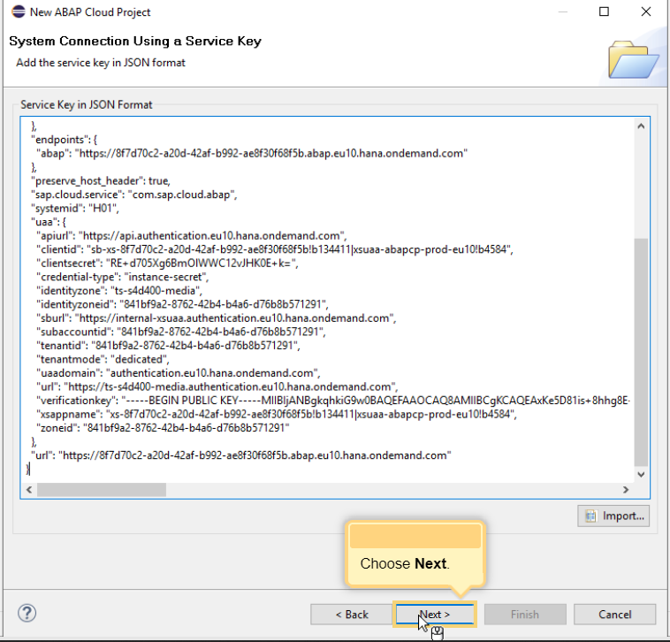

1. Choose log on-page in the Browser option as shown below.

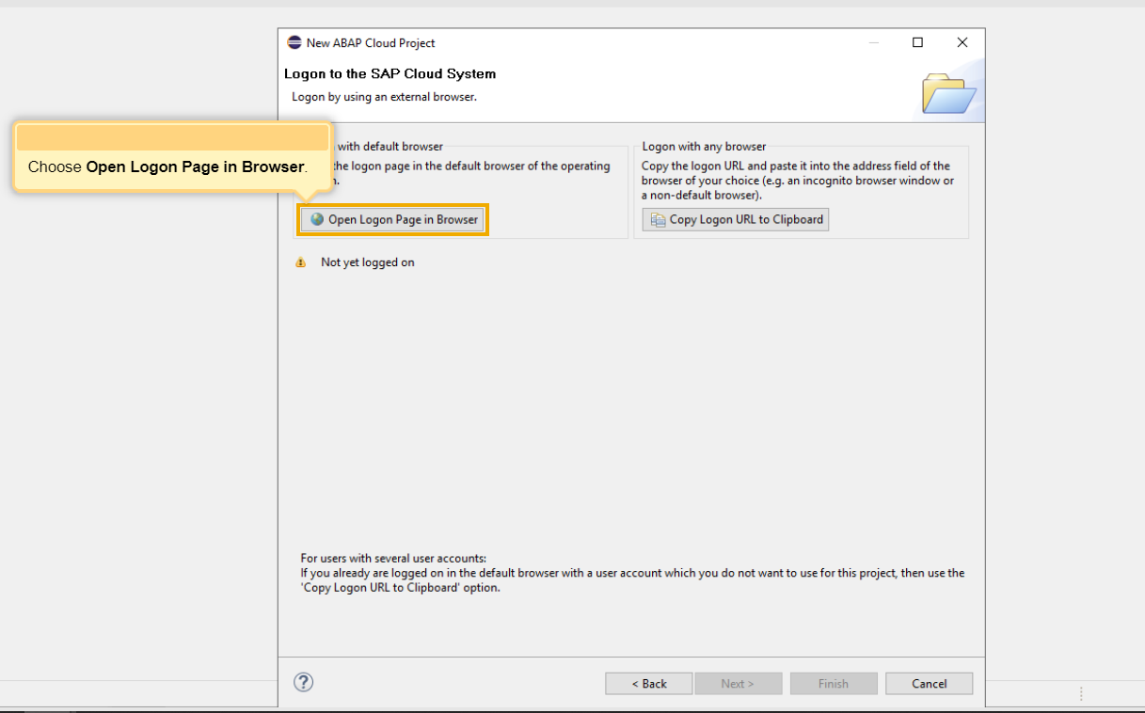

1. Provide your credentials to log-in to SAP BTP, where we get the success message as shown below.

